1.
(a)
Short run marginal cost is the cost to the firm of producing an additional unit of output. When assessing short run marginal cost, we assume that at least one factor of production is fixed. This could mean that, for example, the firm cannot currently buy more capital (machinery) to aid with production. Neoclassical theory dictates that marginal costs initially fall as output increases, then rapidly increase as output further increases. This is because of crowding of a single factor input.
Average variable cost tells us what the average cost of a unit of output is, excluding fixed costs such as energy bills and mortgage payments, for a given level of output. It is calculated by dividing total variable costs by units of output. The average variable cost curve is shown graphically as a U-shape, because of the marginal cost curve. As output increases from low levels, marginal cost is falling, and is therefore below average variable cost. As such, the marginal cost “drags down” the average cost. After a certain level of output, marginal costs rise above average costs, meaning the cost of producing a new unit exceed the average costs of producing all units up until that point. Therefore, the marginal cost “drags up” the average variable cost curve, hence the U-shape. From this intuition, we can derive that average variable costs are minimised when the curve intersects with the marginal cost curve.
Finally, the long-run average cost curve shows the relationship between output and total costs in the long run, when all factors of production are variable.
(c)
Returns to scale refers to how output changes with respect to an equal change in all of the production function inputs. This is an important distinction from the idea of marginal product, which refers to how output changes with respect to a change in only one input, keeping the others fixed. Returns to scale is a concept we use when assessing the relationship between inputs and outputs in the long run, whereas marginal product is a short run concept.
If we doubled all of our factor inputs, and output doubled, this would be an example of constant returns to scale. This is the most common type of return to scale according to the replication argument, which is that it should typically be possible for a firm to exactly replicate its previous production process at a greater scale. Mathematically, where x1 and x2 are factor inputs:
$$tf\left(x1, x2\right)=f(tx1, tx2)$$
Increasing returns to scale exist where increasing inputs by a factor t results in an output increase by a factor > t. An example of increasing returns to scale could the electric vehicles industry. If a firm such as Tesla decided to double both its capital and labour inputs, its output might increase be a factor > 2 because of the potential for specialisation. To illustrate, the firm would have greater scope to employ workers specialised in operating specific machinery, and reducing the need for cross-functional capabilities. This could allow a greater synergy between workers and machines, thus increasing productivity and output. This would be particularly pertinent to a firm such as Tesla as they are developing new, cutting edge technologies which require advanced and specialised capital.
Finally, decreasing returns to scale exist where an increase of all factor inputs results in a proportionally smaller increase in output.

2.
A market can be broadly categorised based on several variables, including the number of firms supplying the market, the barriers to entry for firms seeking to supply the market, and the degree to which suppliers are selling differentiated products. Briefly, as we move through the market structures from perfect competition, monopolistic competition, oligopoly and finally to monopoly, the barriers to entry into the market tend to increase, which reduces the number of firms supplying the market, and the degree of product differentiation increases. Developing this, we typically observe a positive relationship between barriers to entry into the market and the equilibrium price, therefore the supernormal profits firms can make. This is because when barriers to entry are low, new entrants will be incentivised by the potential to make supernormal profits, therefore enter the market and increase industry supply, lowering industry prices and eroding away the supernormal profits of incumbents.
Separately, the idea of collusion refers to a situation whereby in oligopolistic markets, firms can agree to restrict output to command a higher price, which increases group profits. In this sense, through collusion, an oligopoly can essentially become a monopoly. Finally, contestable market theory is the idea that firms in concentrated markets will reach competitive equilibria if there is the potential for new entrants into the market. This stems from the contestable market having low barriers to entry, and therefore even if the market is highly concentrated, firms will not collude, as any supernormal profits would attract new suppliers, therefore increase industry supply and erode away the profits of incumbent firms.
(a)
The best market structure for consumers is a normative consideration. There is a strong case for perfect competition, as this market maximises consumer surplus, as shown in figure 1.1. Additionally, the equilibrium achieved in perfectly competitive markets tends to be of a lower price and higher output, which can benefit consumers. However, one key pitfall of perfectly competitive markets is the lack of choice they present to the consumer. A perfectly competitive market has many firms selling a homogenous good, and therefore consumers are not able to purchase a product tailored to their own tastes, even if they would willingly pay more for this. As such, only when consumers do not place any value on product differentiation could perfect competition be considered the best market structure.
On this note, monopolistic competition is beneficial to consumers as it provides them with a much larger degree of product choice. This is because firms in monopolistic competition can create short-run barriers to entry through differentiating their products and creating brand loyalty. This differentiation allows firms to maintain supernormal profits in the short-run, and encourages them to invest in research and development to make their products distinct from competitors’. As such, the benefit to consumers is two-fold; both increased choice, and increased product quality as firms invest profits into research and development to further differentiate. One criticism of monopolistic competition, however, if that often the differentiation is superficial only, and therefore necessitates an inefficient use of resources. For example, money spent on advertising to create brand loyalty to a product fundamentally identically to a substitute is not an effective use of resources for society.
(b)
Highly concentrated markets such as oligopolies and monopolies can be beneficial to society, if effectively regulated. First, monopolists are major employers, and can create significant multiplier effects in local economies through the wages they provide to employees. Further, this employment is typically more stable than in monopolistically competitive or perfectly competitive industries. This is beneficial for both workers and the firm, with workers having financial stability and being able to continually develop their efficiency through repetition, as opposed to constantly having to switch firms or industries. Second, with effective tax regulation, monopolists can be a good source of government revenue, due to the enduring supernormal profits they make. Alternatively, or in addition, government can introduce tax breaks for monopolists who reinvest their profits into R&D, which can create long-term benefits to societies. For example, as Microsoft is a monopolist, it was able to invest heavily into the development of new products and technologies which have improved the lives of many people in societies around the world. Finally, for some industries with a high minimum efficient scale, the only way to satisfy industry demand and remain profitable is by exploiting massive economies of scale. Such markets can be referred to as ‘natural monopolies’
However, as figure 1.2 shows, a profit maximising-monopolist creates a welfare loss of area DWL, because not all of the consumer surplus is transferred into producer surplus – some is “lost”. That is, for output levels beyond the monopolist’s, there are additional units for which the benefits to the consumer exceed the cost to the firm, and thus the monopolist is allocatively inefficient. Therefore, whether monopolies provide the benefits listed, or instead merely exploit consumers, will depend on the ability of independent regulators to effectively enforce competitive standards. In the UK, for example, the energy sector is closely regulated by OFCOM, which allows price increases in line with inflation.
However, there is a risk of regulatory capture, and taxpayer funds must cover the cost of regulation
(c)
Perhaps the only positive question here is which market structure is best for firms. Classical theories regarding the objectives of the firm, such as profit maximisation or revenue maximisation, are most easily achieved in highly concentrated markets, ideally monopolies. This is because barriers to entry prevent new firms from entering and eroding away the monopolist’s supernormal profits, which it can therefore maintain in the long run. This is shown graphically through the transfer of some consumer surplus into producer surplus, as the monopolist restricts output. Additionally, the monopolist faces no competition for market share, so can increase its revenues up until the point of market saturation if it so wishes. On the other hand, even alternative objectives, such as profit satisficing or corporate social objectives, are generally most easily achieved from the position of a monopolist. Because they are large employers generating significant tax revenues for governments, monopolists tend to have more market and political power, for example when lobbying government to achieve any commercial or social objectives.
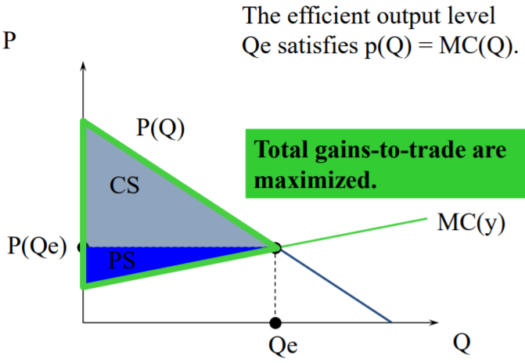
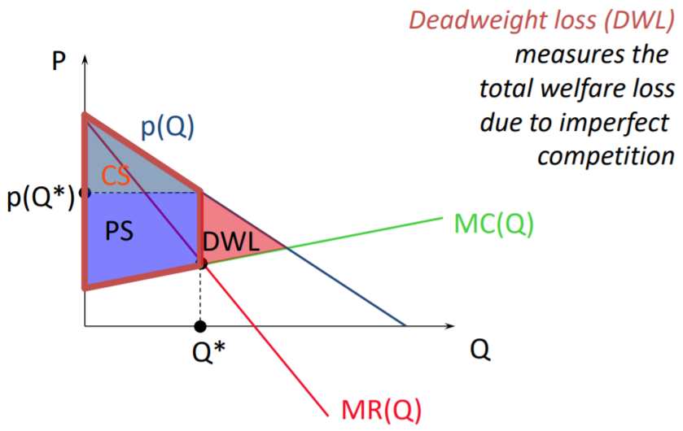

Figure 1.1 Figure 1.2
3.
Figure 3.1 shows the payoffs for the entrant and incumbent in each of the four situations. Here, there are two Nash equilibria: enter, accept and stay out, fight. These are Nash equilibria because each player is choosing their optimal strategy, after assuming their opponent will do the same. This means that neither player has an incentive to change their strategy from either of these outcomes, and therefore the Nash equilibria are steady-state outcomes, immune to unilateral deviation.
As figure 3.1 shows, if the game were simultaneous, we would have two Nash equilibria. However, the game of entry deterrence is sequential, with the entrant first choosing whether to enter or not, and then the incumbent choosing whether to fight or not. This is illustrated in figure 3.2. Assuming rationality, the entrant will choose to enter, because if it does not, its payoff will be 1. If it does, its payoff will be either 0 or 2, depending on whether the incumbent fights or not. If the entrant enters, the incumbent’s optimal strategy is to accept, as this increases its payoff from 0 to 1. Therefore, assuming the incumbent will seek to optimise his own utility, the entrant will enter, and achieve the Nash equilibrium of enter, accept.
However, if the incumbent can create a credible threat to fight, the entrant should not enter, as in this situation its utility would be 0, as opposed to the 1 it gains from not entering. The incumbent could create this threat by creating expectations of fighting, by historically responding aggressively to potential entrants. Alternatively, the incumbent could engage in a pricing strategy to deter would-be entrants. As shown in figure 3.3, the incumbent is further along its LRAC curve than the new entrant, as its output is higher. As such, the incumbent could produce beyond its profit-maximising output, resulting in a price P2 as opposed to P1. This price is below the average cost of a new entrant (Ce), but above its own average cost (Ci). The result is that the incumbent retains its supernormal profits, albeit a smaller amount (shown by the shaded region B), and any entrant would be faced with negative profits (shown by the shaded region A), therefore is deterred from entering. In terms of our model, this could result in changes in the payoff values to both players, as shown in figure 3.4, resulting in a new Nash equilibrium of stay out, fight.
In practice, limit pricing may not work if the potential entrant is a large multi-national who is willing to sustain an initial loss before achieving the economies of scale sufficient to make supernormal profits. This is because such companies have large cash reserves, or can cross-subsidise ventures using their more profitable products. As such, if the entrant sees the market as attractive it could enter, despite limit pricing strategies by the incumbent. Further, in industries which do not have substantial economies of scale, limit pricing would be less effective. This is because the LRAC curve is flatter, and therefore incumbents with higher outputs will nevertheless be unable to make profits at the price level low enough to induce negative profits for new entrants.

